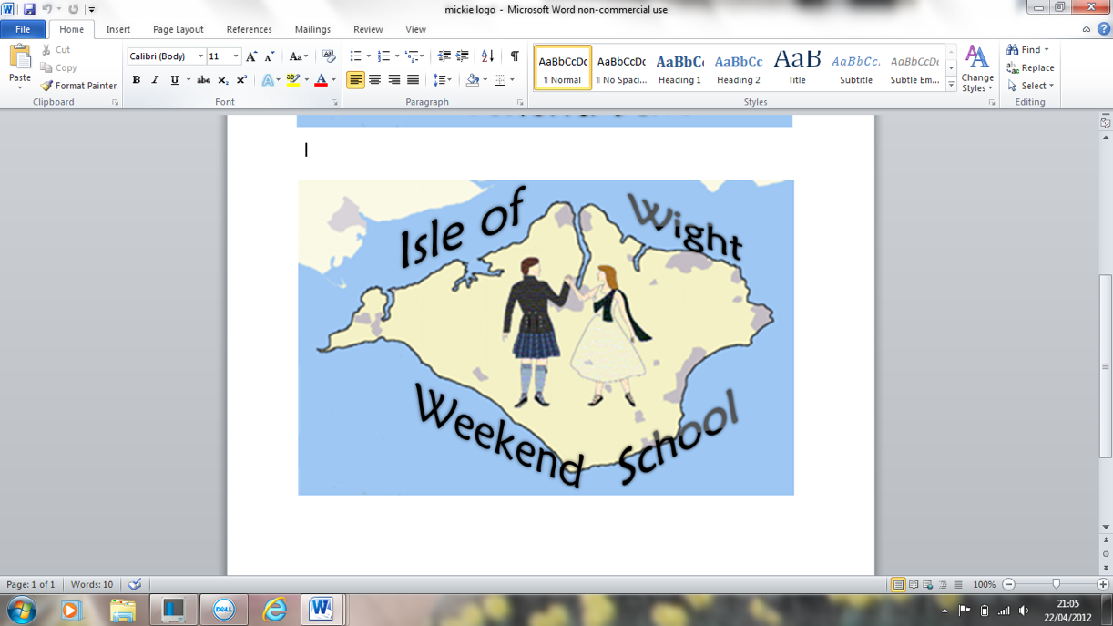 **13th- 15th February 2026**

**VENUE: Shanklin Hotel, Shanklin, Isle of Wight. PO37 6DP**

**TEACHERS: RAPHAELLE ORGERET and ERIC FINLEY**

**MUSICIANS: IAN and JUDITH MUIR**

**BAND:** (for social dances) **THE CRAIGELLACHIE BAND**

**WEBSITE:** www.craigellachie-band.co.uk/isle_of_wight.html

**THE WEEKEND** is designed to give those with a good working knowledge of steps and formations the opportunity to improve their technique, learn new dances and enjoy all social aspects of Scottish Country Dancing. We start with a wine reception before dinner on Friday, and finish after lunch on Sunday. There are classes each morning and a social dance each evening.

We endeavour to evenly arrange participants into two mixed ability classes on Saturday and Sunday mornings. To assist with this please indicate your ability as accurately as possible in the boxes below.

As socialising is a large, and important, part of Scottish country dancing we are keen to invite non-hotel residents to join in the non-dancing parts of the weekend. We would therefore like to draw your attention to the various options to add lunch onto your morning class and/or the wine reception and dinner onto the evening social dances.

We are happy to accept applications from people wishing to attend one or all sessions.

**COST:** As specified on reverse and are per person.

Due to the popularity of the weekend, bookings cannot be secured until full payment has been received. If, for any reason, you need to cancel your booking we will endeavour to refund your fee. Cancellations made after 1st February 2026 will be charged in full.

**OUR TEACHERS AND MUSICIANS:**

**Raphaelle Orgeret:** From Lyon in France, Raphaelle was introduced to Scottish country dancing from an early age, and now teaches both the Branch class and children’s class in Lyon. She has taught at various RSCDS events such as Summer School, Winter School and Spring Fling, as well as workshops across Europe.  She has been lucky enough to teach as far away as Australia, TAC and California.

**Eric Finley:** Eric started dancing at the age of twelve. He joined North West Ayrshire branch as it was then and danced in the demonstration team. He has taught the Branch class for several years and his very first away teaching was the Isle of Wight Weekend.  Since then he has been invited to teach in Australia, Canada, North America and Europe, as well as teaching regularly at Summer School.

**Ian and Judith Muir:** Ian and Judith both started playing at an early age for country dancing and both have considerable experience playing for classes, weekend, Summer and Winter Schools both here and abroad.

**FOR MORE INFORMATION:** Contact Aileen Napper (01983 614993) or

Catherine Packwood-Bluett (07810 628328)

**APPLICATIONS:** Postal application forms and full payment via cheque should be sent to:Mrs Catherine Packwood-Bluett, 33 Highfield Rise, Shrewton, Salisbury, Wilts, SP3 4DZ

**OR**

Bank transfer payments can be made with email application to**:** [**iowsdwe@hotmail.com**](mailto:iowsdwe@hotmail.com)

Further information about the weekend, including the dance programmes, will be issued at a later date following receipt of your application.

**13th – 15th February 2026 APPLICATION FORM**

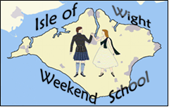

**Please complete using BLOCK CAPITALS, thank you.**

**Name**…………………………………………………………………………………………………………

**Address**………………………………………………………………………………………………………

…………………………………………………………............................................................

**Tel No**…………………………………………….................... **Email** …………….............................................................................

**Standard of dancing if attending classes (please tick)**



**Advanced:** Energetic dancers able to perform steps and all formations with a high level of technical ability which can be sustained throughout the class.

**Intermediate:** Dancers with a reasonable knowledge of most steps and formations, able to follow instructions with confidence and without hindering fellow dancers (you may well have the same level of expertise as detailed abovebut find this difficult to sustain)*.*



**SATURDAY MORNING TUITION @ £10.00** **INCLUDING BUFFET LUNCH @ £25.00**



**SUNDAY MORNING TUITION @ £10.00 INCLUDING ROAST LUNCH @ £29.00**

**FRIDAY NIGHT**



**SOCIAL DANCE @ £11.00 INCLUDING DINNER & WINE RECEPTION @ £32.00**

**SATURDAY NIGHT**

**SOCIAL DANCE @ £11.00** **INCLUDING DINNER & WINE RECEPTION @ £32.00**



I enclose a cheque for £…………………

**Please make cheques payable to ‘I.W. Weekend School’**

**Send to: Mrs Catherine Packwood-Bluett, 33 Highfield Rise, Shrewton, Salisbury, Wilts, SP3 4DZ**

**\*\*\*\*\*\*\*\*\*\*\*\*\*\*\*\*\*\*\*\*\*\*\*\***

**BANK TRANSFERS:** Payments must be made **before** emailing.

Bank transfer reference*………………………………………………….. Date transfer made ……………………..

**\***To enable us to identify your payment please reference your transfer with your surname followed by initials.

Total amount transferred £…………………………………….

Please make Bank Transfer Payments using the following information:-

**Sort Code:** 54 – 41 – 19 **Account number:** 53373898 **Account name:** IW WEEKEND SCH

**Email Applications:**

Please complete all of the above application form before emailing to:[**iowsdwe@hotmail.com**](mailto:iowsdwe@hotmail.com)

During the weekend we will be taking photographs and video clips for publicity and social media purposes. If you do **not** wish to be included in any such publicity then please tick this box and make yourself known to the organisers upon arrival.